20BDS0146

VENNELA G

ADVANCED C PROGRAMMING

L47+48

MIDTERM TEST

**GROUP B**

**QUESTION 1**

Amicable numbers are found in pairs. A given pair of numbers is Amicable if the sum of the proper divisors (not including itself) of one number is equal to the other number and vice – versa.

**For example,**220 & 284 are amicable numbers

First we find the proper divisors of 220: 220:1, 2, 4, 5, 10, 11, 20, 22, 44, 55, 110

1+ 2 + 4 + 5 + 10 + 11 + 20 + 22 + 44 + 55 + 110 = 284

Now, 284: 1, 2, 4, 71, 142

1 + 2 + 4 + 71 + 142 = 220

Write a C program to check that the input pair of numbers is amicable.

**CODE:**

#include<stdio.h>

int main()

{int a,b;

int count=0;

int count1=0;

int sum=0;int sum1=0;

scanf("%d\n",&a);

scanf("%d",&b);

for(int i=1;i<a;i++)

{if((a%i)==0)

{

sum=sum+i;

}

}

for(int j=1;j<b;j++)

{if((b%j)==0)

{sum1=sum1+j; }

}

if(sum==b && sum1==a)

{printf("The pair of numbers are amicable");}

else

{printf("The pair of numbers are not amicable");}

return 0;

}

OUTPUT:

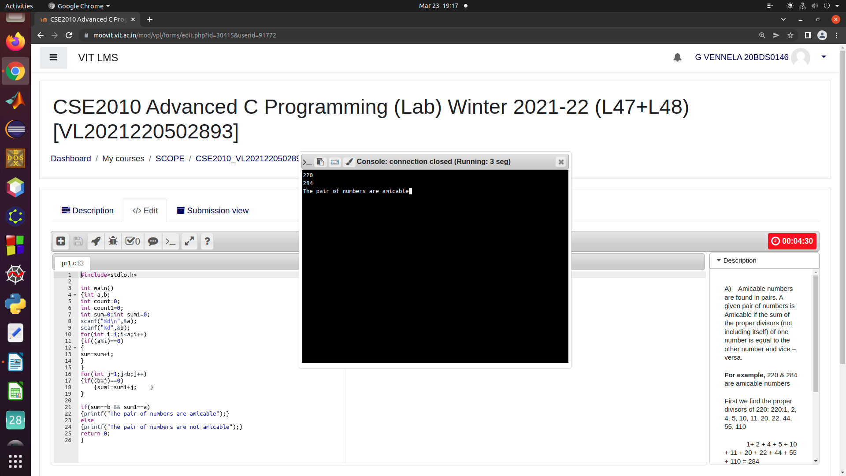

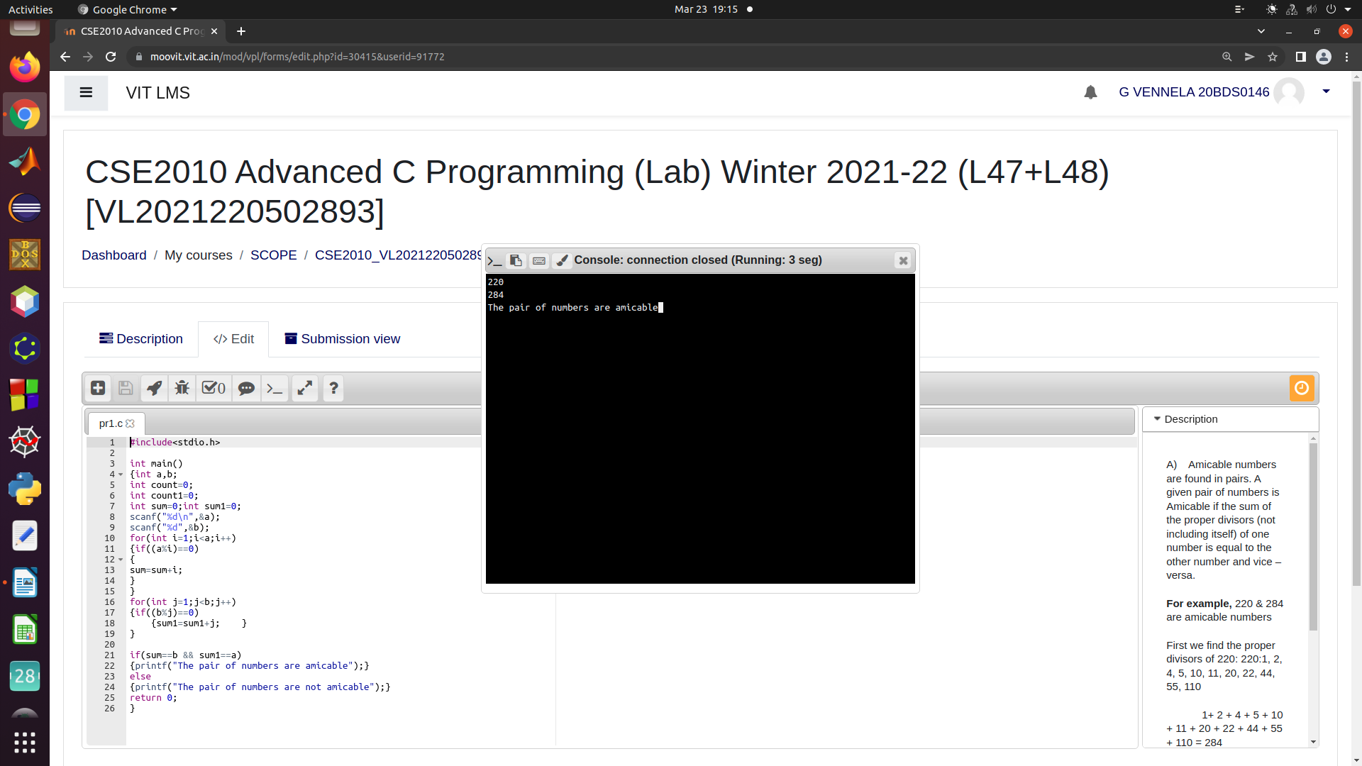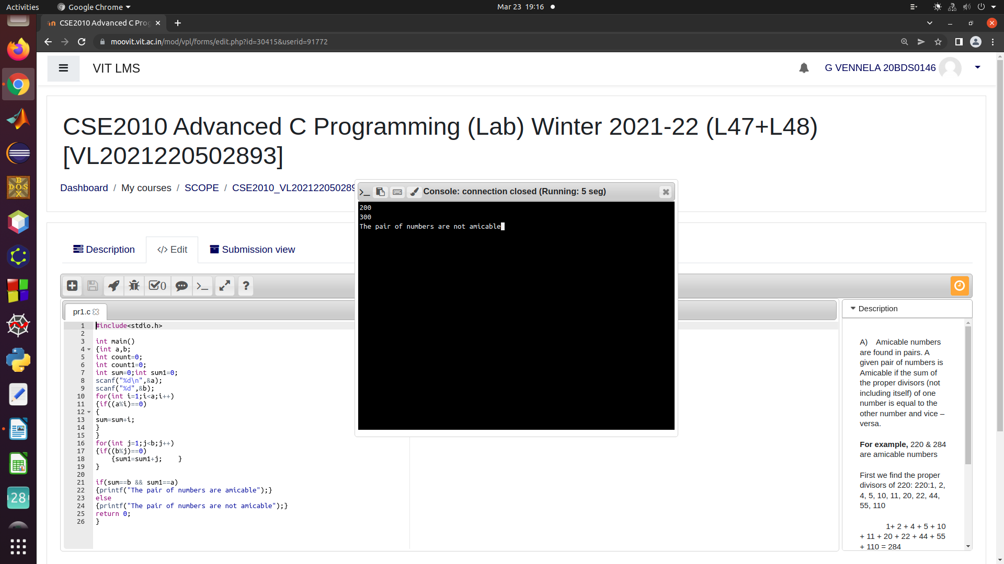

2.

Write a C program to accept the emp_id, age, basic salary of an employee from the user. Write a  function to calculate the gross salary (basic+HRA+DA)on the following basis:

            Basic                            HRA               DA

            1 - 4000                       10%                 50%

            4001 - 8000                 20%                 60%

            8001 - 12000               25%                 70%

            12000 and above        30%                 80%

Then you should print,

            Emp-id            age                  gross salary

             22101             35                    XXXXX

            22102              54                    YYYYY

            22103              42                    ZZZZZ

code:

#include<stdio.h>

int calc(int x)

{int a;

if(x>0 && x<=4000)

{a=x+(0.1*x)+(0.5*x);}

if(x>=4001 && x<=8000)

{a=x+(0.2*x)+(0.6*x);}

if(x>=8001 && x<=12000)

{a=x+(0.25*x)+(0.7*x);}

if(x>12000)

{a=x+(0.3*x)+(0.8*x);}

return a;

}

int main()

{int emp_id;

int age;

int basic_salary;int gross_salary;

printf("Emp-id age gross salary\n");

for(int i=0;i<3;i++)

{scanf("%d\n",&emp_id);

scanf("%d\n",&age);

scanf("%d",&basic_salary);

gross_salary=calc(basic_salary);

printf("%d %d %d",emp_id,age,gross_salary);

printf("\n");}

return 0;

}

OUTPUT:

